Lab 6.1: MongoDB AS NOSQL Database
Date: 28/11/2025
Objectives:
- To be able to install, connect and manage mongodb instance on windows.
- To be able to understand about database, collection, and document in a document based (NoSQL) database.
- To be able to create, update, delete, and view document in monogodb database using mongo shell and compass (GUI) (ps: for my case: docker for mongo and vs code for accessing mongo in gui instead of compass)

CODE:
<test> USE <database_name>;
The USE <db> command will switch the database if it already exists or creates a new database with that name

Code:
test> use OIC;
switched to db OIC
OIC> show collections;
lecturers
Students
OIC> db.createCollection("Student");
{ ok: 1 }
OIC> show collections;
lecturers
Student
Students
OIC> db.lecturers.insertOne({id:100, name: "Sandesh Khatiwada", course : ["TOC", "DBMS"]}) ;
{
acknowledged: true,
insertedId: ObjectId('69290af7fb1c1302ea9dc29d')
}
OIC> db.lecturers.find().pretty();
[
{
_id: ObjectId('6927ba9ed5e607528fa3bb5d'),
roll: 101,
name: 'Radha',
salary: 85000,
hire_date: ISODate('2004-02-03T00:00:00.000Z')
},
{
_id: ObjectId('6927bae4f21707528eba3c42'),
roll: 102,
name: 'Sandesh',
salary: 85000,
age: 44,
hire_date: ISODate('2004-02-03T00:00:00.000Z')
},
{
_id: ObjectId('69290af7fb1c1302ea9dc29d'),
id: 100,
name: 'Sandesh Khatiwada',
course: [ 'TOC', 'DBMS' ]
}
]
OIC>
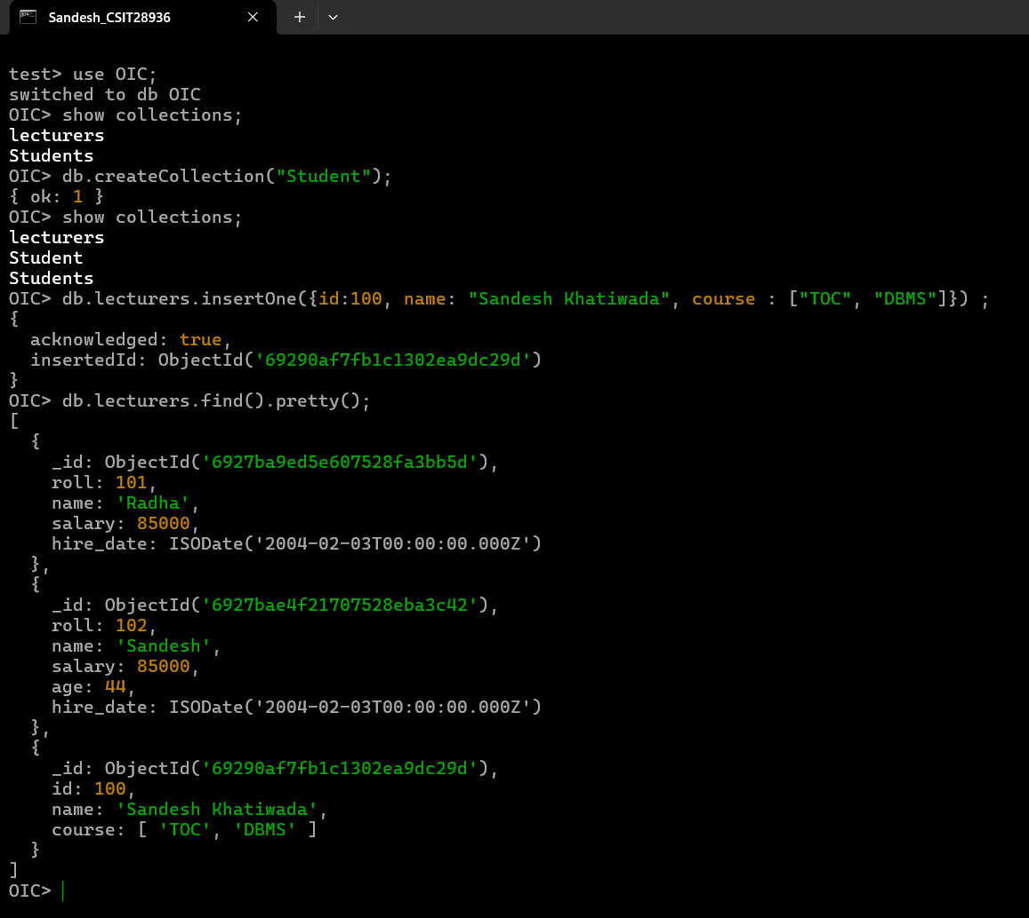

Code: //insert many
db.lecturers.insertMany([{ID:200 ,name: "Dhiraj", salary: 100000},
{ID:201, name: "Sandesh", salary: 2200},
{ID:202, name: "Rajesh", salary:null, phone: 9812344555}])

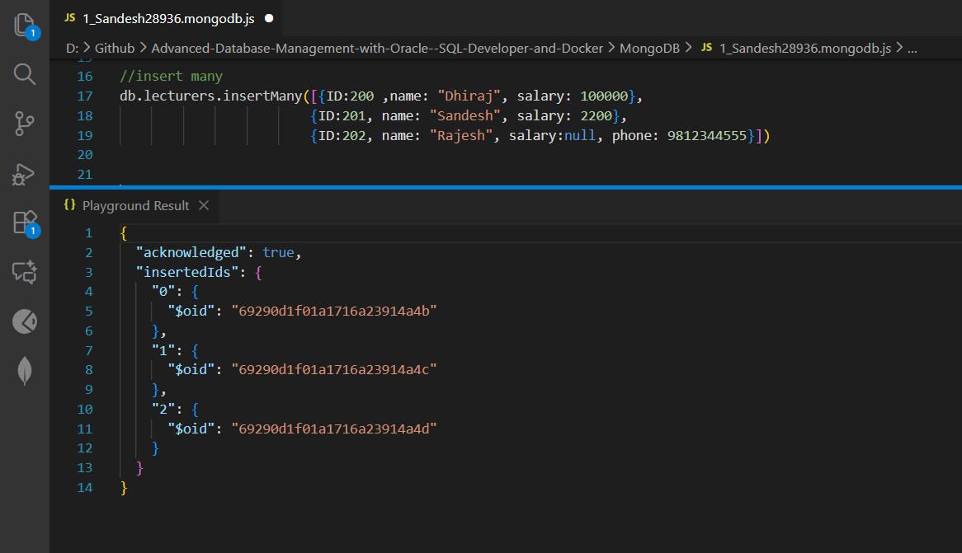

Find the list of lecturers whose salary is greater than 80000
// Find the list of lecturers whose salary is greater than 80000
//$gt, $lt, $gte, $lte, $eq, $nq
db.lecturers.find({salary: {$gt: 80000}}, {name: true, salary: true, _id: false})
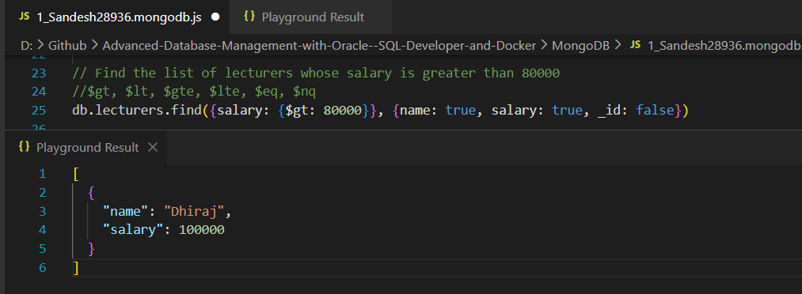

Find:
//sort
db.lecturers.find({name: "Sandesh"})
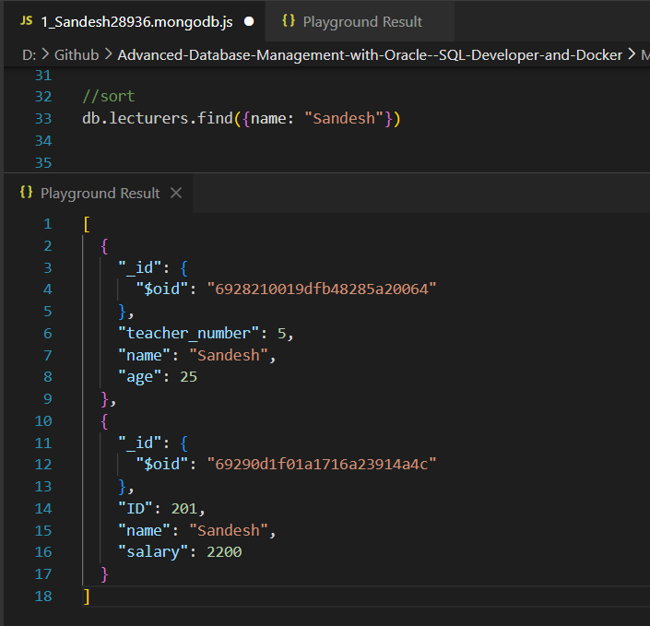

- Update Documents:
- Update single document
db.lecturers.updateOne(
{ name: "Sandesh" }, { $set: { salary: 95000 } })
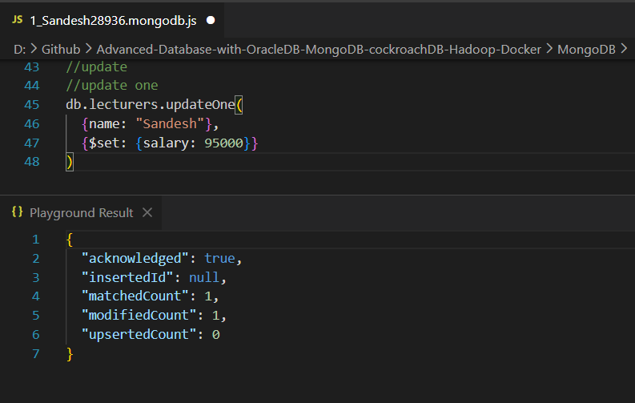

- Update multiple documents
db.lecturers. updateMany(
{salary: {$gt: 80000}}, {$inc: {salary: 5000}})
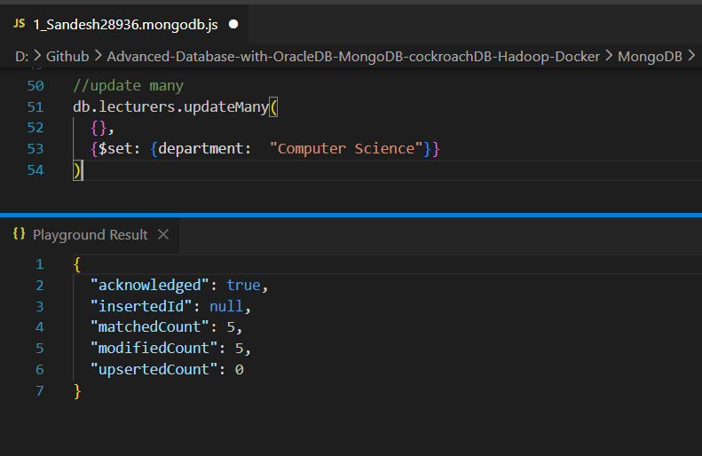

- Verify updates
db.lecturers.find().pretty()
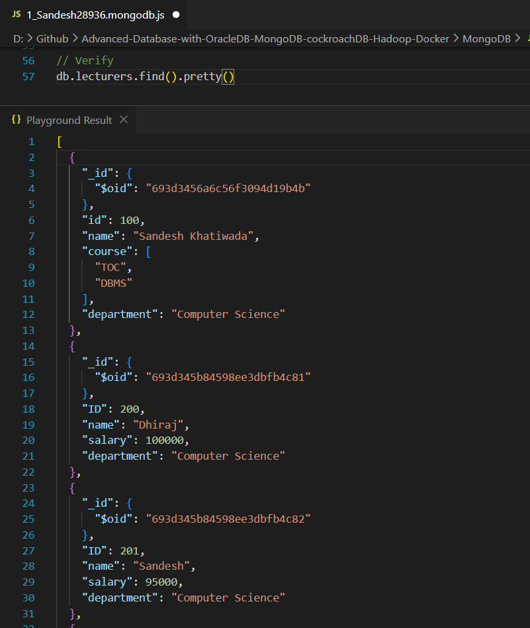

- Delete Documents
- Delete one document
db.lecturers.deleteOne({_id: ObjectId(‘693d345b84598ee3dbfb4c84’)})
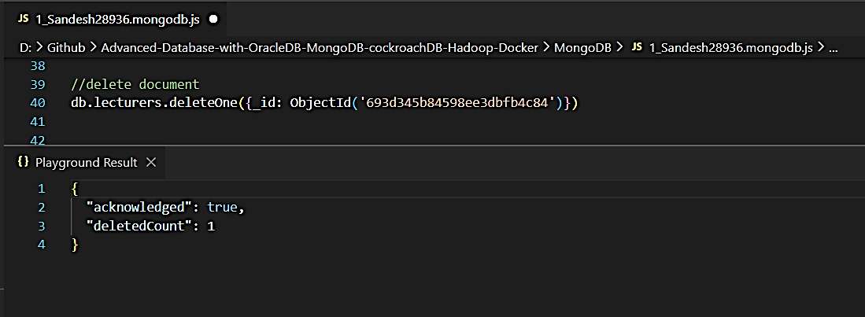
- Delete multiple documents:
db.lecturers.deleteMany({ID: {$in: [201, 202, 204]}})
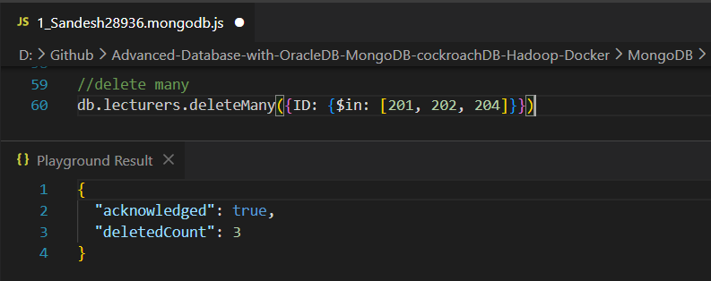

Verify deletion:
- Verify deletion
db.lecturers.find().pretty()
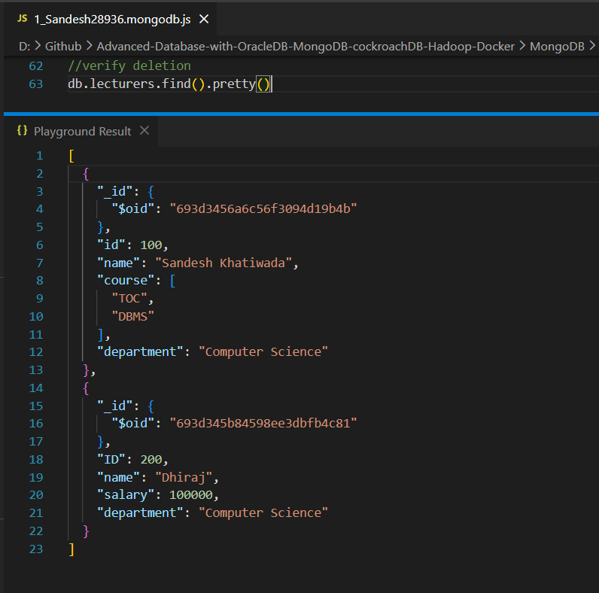

Conclusion:
MongoDB was successfully used as a NoSQL database using Docker.
Databases and collections were created and managed effectively.
CRUD operations were performed using MongoDB shell,
demonstrating MongoDB’s flexibility in handling structured
and semi-structured data.

